**DICO mysql-connector 1.0.0™**

**TEAM**

TRAORE

CHEICK

OUMAR TIDIANE

**mR. konate**

**Certificate**

This is to certify that ***SHIVANSH, VIVEKANAND & VISHWASH*** of class XII-A have successfully completed their Computer Science project on ***“Library Database Management Software”*** under the guidance of Mrs. Leena. This is certified to be the bonafide work of the students in the Computer Science laboratory during the academic year 2020-21.

***Mrs. Leena***

**(Computer Science Teacher)**

**EXAMINER’S PRINCIPAL**

**SIGNATURE**

**ACKNOWLEDGEMENT**

We would like to express my sincere gratitude to my teacher Mrs. Leena for providing invaluable guidance, comments and suggestions. We would specially thank her for constantly motivating us and providing us an overview of the project work.

Our sincere thanks to our principal Mr. Sunil Kumar V.S for extending every possible support for the completion of the project.

*Shivansh, vivekanand & Vishwash*

**XII-A, KV2 AFS JALAHALLI(E)**

|  |  |  |
| --- | --- | --- |
| **1.** | **ABOUT THE PROJECT** | **4** |
| **2.** | **Source Code** | **5-31** |
| **3.** | **Project Screenshots** | **32-39** |
| **4.** | **Future Scope** | **40** |
| **5.** | **System Requirements** | **41** |
| **6.** | **Bibliography** | **42** |

**ABOUT THE PROJECT**

This project provides the information about ‘**Library Workbench 6.8.3™’**.

This allows storage and management of details of all books.Book details like Serial Number, Name, Genre, Price, Author, etc. are stored in the ‘**MySQL**’ database and connected via **Python** on front end.

Details can be added, deleted or modified based on user requirement. Search of any particular book is possible.

Rich Graphical User Interface (**GUI**) of the program created using python’s **tkinter**, makes it user friendly and easy to use.

**Source Code**

**#Library Workbench Created by Shivansh Singh**

**from tkinter import \***

**import mysql.connector**

**from tkinter import ttk**

**from PIL import ImageTk, Image**

**from tkinter import messagebox**

**def combine_funcs(*funcs):**

**def combined_func(*args, **kwargs):**

**for f in funcs:**

**f(*args, **kwargs)**

**return combined_func**

**root=Tk()**

**root.iconbitmap('D:/Study/CS Project/d.ico')**

**root.title('Library Workbench 6.8.3™')**

**my_img=ImageTk.PhotoImage(Image.open("D:\\Study\\CS Project\\Library2.jpg"))**

**my_label= Label(image=my_img)**

**my_label.pack(expand=YES)**

**root.geometry('800x620') #fixing size of window**

**root.geometry('+200+50') #fixing default location on screen**

**root.resizable(0, 0) #denying resizing**

**frame=LabelFrame(root,text='Enter Password',padx=5,pady=3)**

**frame.pack(anchor=S+E)**

**e=Entry(frame,font=("monospaced", 10),fg='#292a37',bg='#cfd2e6',border=7,width=75)**

**e.grid(row=1,column=1,padx=10,pady=15)**

**def password():**

**if e.get()=='XTreme683':**

**return()**

**else:**

**messagebox.showerror('Error 31719','Incorrect Password: Acesss Denied')**

**def net():**

**global e**

**if e.get()=='XTreme683':**

**import tkinter as tk**

**root = tk.Tk()**

**root.geometry('800x620') #fixing size of window**

**root.geometry('+200+50') #fixing default location on screen**

**root.resizable(0, 0) #denying resizing**

**root.iconbitmap('D:/Study/CS Project/d.ico')**

**root.title('Library Workbench 6.8.3™')**

**frame=LabelFrame(root,text='Main Menu',padx=17,pady=7)**

**frame.pack(anchor=S+E)**

**ss=Button(frame,text='Add a Book',font=("Helvetica", 10),fg='#f8dede',bg='#000000',border=7,height=5,width=90,command=but)**

**ss.grid(row=1,column=0,padx=5,pady=15)**

**fs=Button(frame,text='Search a Book',font=("Helvetica", 10),fg='#f8dede',bg='#000000',border=7,height=5,width=90,command=search_customers)**

**fs.grid(row=2,column=0,padx=5,pady=15)**

**gs=Button(frame,text='Delete a book',font=("Helvetica", 10),fg='#f8dede',bg='#000000',border=7,height=5,width=90,command=delx)**

**gs.grid(row=3,column=0,padx=5,pady=15)**

**hs=Button(frame,text='Update a Book',font=("Helvetica", 10),fg='#f8dede',bg='#000000',border=7,height=5,width=90,command=upnow)**

**hs.grid(row=4,column=0,padx=5,pady=15)**

**def but():**

**import tkinter as tk**

**root = tk.Tk()**

**root.geometry('800x620') #fixing size of window**

**root.geometry('+200+50') #fixing default location on screen**

**root.resizable(0, 0) #denying resizing**

**root.iconbitmap('D:/Study/CS Project/d.ico')**

**root.title('Library Workbench 6.8.3™')**

**frame=LabelFrame(root,text='Add Details',padx=17,pady=7)**

**frame.grid()**

**Srnolabel= Label(root,text='Srno',font=('Helvetica',20))**

**Srnolabel.grid(row=0,column=0)**

**Namelabel= Label(root,text='Name',font=('Helvetica',16))**

**Namelabel.grid(row=1,column=0)**

**Authorlabel= Label(root,text='Author',font=('Helvetica',16))**

**Authorlabel.grid(row=2,column=0)**

**Pricelabel= Label(root,text='Price',font=('Helvetica',16))**

**Pricelabel.grid(row=3,column=0)**

**Genrelabel= Label(root,text='Genre',font=('Helvetica',16))**

**Genrelabel.grid(row=4,column=0)**

**Languagelabel= Label(root,text='Language',font=('Helvetica',16))**

**Languagelabel.grid(row=5,column=0)**

**Almirah_Nolabel= Label(root,text='Almirah_No',font=('Helvetica',16))**

**Almirah_Nolabel.grid(row=6,column=0)**

**Shelf_Nolabel= Label(root,text='Shelf_No',font=('Helvetica',16))**

**Shelf_Nolabel.grid(row=7,column=0)**

**Srno= Entry(root,width=52,font=('Helvetica',16),border=10)**

**Srno.grid(row=0,column=1,padx=20,pady=10)**

**Name= Entry(root,width=52,font=('Helvetica',16),border=10)**

**Name.grid(row=1,column=1,padx=20,pady=10)**

**Author= Entry(root,width=52,font=('Helvetica',16),border=10)**

**Author.grid(row=2,column=1,padx=20,pady=10)**

**Price= Entry(root,width=52,font=('Helvetica',16),border=10)**

**Price.grid(row=3,column=1,padx=20,pady=10)**

**Genre= Entry(root,width=52,font=('Helvetica',16),border=10)**

**Genre.grid(row=4,column=1,padx=20,pady=10)**

**Language= Entry(root,width=52,font=('Helvetica',16),border=10)**

**Language.grid(row=5,column=1,padx=20,pady=10)**

**Almirah_No= Entry(root,width=52,font=('Helvetica',16),border=10)**

**Almirah_No.grid(row=6,column=1,padx=20,pady=10)**

**Shelf_No= Entry(root,width=52,font=('Helvetica',16),border=10)**

**Shelf_No.grid(row=7,column=1,padx=20,pady=10)**

**def submit():**

**mydb=mysql.connector.connect(host='localhost',user='root',passwd='XTreme365',database='Library')**

**my_cursor=mydb.cursor()**

**h=int(Srno.get())**

**a=str(Name.get())**

**b=str(Author.get())**

**c=int(Price.get())**

**d=str(Genre.get())**

**e=str(Language.get())**

**f=int(Almirah_No.get())**

**g=int(Shelf_No.get())**

**my_cursor.execute('''insert into books values("%d","%s","%s","%d","%s","%s","%d","%d") '''%(h,a,b,c,d,e,f,g))**

**mydb.commit()**

**mydb.close()**

**Srno.delete(0,END)**

**Name.delete(0,END)**

**Author.delete(0,END)**

**Price.delete(0,END)**

**Genre.delete(0,END)**

**Language.delete(0,END)**

**Almirah_No.delete(0,END)**

**Shelf_No.delete(0,END)**

**submit_btn=Button(root,text='Add Record',command=submit,fg='#f8dede',bg='#000000',font=('Helvetica',20),height=1)**

**submit_btn.grid(row=8,column=1,padx=10,pady=10,ipadx=100,sticky=S+E)**

**back_btn=Button(root,text='Back',fg='#f8dede',bg='#000000',font=('Helvetica',20),height=1,command=root.destroy)**

**back_btn.grid(row=8,column=0,padx=5,pady=5)**

**def but1():**

**mydb=mysql.connector.connect(host='localhost',user='root',passwd='XTreme683',database='Library')**

**my_cursor=mydb.cursor()**

**import tkinter as tk**

**root = tk.Tk()**

**root.geometry('800x620') #fixing size of window**

**root.geometry('+200+50') #fixing default location on screen**

**root.resizable(0, 0) #denying resizing**

**root.iconbitmap('D:/Study/CS Project/d.ico')**

**root.title('Library Workbench 6.8.3™')**

**frame=LabelFrame(root,text='Add Details',padx=17,pady=7)**

**frame.grid()**

**Srnolabel= Label(root,text='Enter Srno to be altered',font=('Helvetica',20))**

**Srnolabel.grid(row=0,column=0)**

**Namelabel= Label(root,text='Enter New Name',font=('Helvetica',16))**

**Namelabel.grid(row=1,column=0)**

**Authorlabel= Label(root,text='Enter New Author',font=('Helvetica',16))**

**Authorlabel.grid(row=2,column=0)**

**Pricelabel= Label(root,text='Enter New Price',font=('Helvetica',16))**

**Pricelabel.grid(row=3,column=0)**

**Genrelabel= Label(root,text='Enter New Genre',font=('Helvetica',16))**

**Genrelabel.grid(row=4,column=0)**

**Languagelabel= Label(root,text='Enter New Language',font=('Helvetica',16))**

**Languagelabel.grid(row=5,column=0)**

**Almirah_Nolabel= Label(root,text='Enter New Almirah_No',font=('Helvetica',16))**

**Almirah_Nolabel.grid(row=6,column=0)**

**Shelf_Nolabel= Label(root,text='Enter New Shelf_No',font=('Helvetica',16))**

**Shelf_Nolabel.grid(row=7,column=0)**

**Srno= Entry(root,width=52,font=('Helvetica',10),border=10)**

**Srno.grid(row=0,column=1,padx=20,pady=10)**

**Name= Entry(root,width=52,font=('Helvetica',10),border=10)**

**Name.grid(row=1,column=1,padx=20,pady=10)**

**Author= Entry(root,width=52,font=('Helvetica',10),border=10)**

**Author.grid(row=2,column=1,padx=20,pady=10)**

**Price= Entry(root,width=52,font=('Helvetica',10),border=10)**

**Price.grid(row=3,column=1,padx=20,pady=10)**

**Genre= Entry(root,width=52,font=('Helvetica',10),border=10)**

**Genre.grid(row=4,column=1,padx=20,pady=10)**

**Language= Entry(root,width=52,font=('Helvetica',10),border=10)**

**Language.grid(row=5,column=1,padx=20,pady=10)**

**Almirah_No= Entry(root,width=52,font=('Helvetica',10),border=10)**

**Almirah_No.grid(row=6,column=1,padx=20,pady=10)**

**Shelf_No= Entry(root,width=52,font=('Helvetica',10),border=10)**

**Shelf_No.grid(row=7,column=1,padx=20,pady=10)**

**def search_customers():**

**import tkinter as tk**

**root = tk.Tk()**

**root.geometry('800x620') #fixing size of window**

**root.geometry('+200+50') #fixing default location on screen**

**root.resizable(0, 0) #denying resizing**

**root.iconbitmap('D:/Study/CS Project/d.ico')**

**root.title('Library Workbench 6.8.3™')**

**frame=LabelFrame(root,text='Search Books',padx=50,pady=50)**

**frame.grid()**

**def search_now():**

**from tkinter import messagebox**

**mydb=mysql.connector.connect(host='localhost',user='root',passwd='XTreme365',database='Library')**

**my_cursor=mydb.cursor()**

**selected=drop.get()**

**if selected=='Search by...':**

**messagebox.showerror('Critical Error 20620 ','Choose a Search valid Option')**

**if selected=='Name':**

**searched=search_box.get()**

**a=str(searched)**

**my_cursor.execute('''SELECT * from books where Name="%s"'''%(a))**

**result=my_cursor.fetchall()**

**for index, x in enumerate(result):**

**num=0**

**index+=2**

**Srno_reference=str(x[0])**

**for y in x:**

**lookup_label=Label(frame, text=y)**

**lookup_label.grid(row=index+4,column=num+1)**

**num+=1**

**if not result:**

**result=messagebox.showwarning('Warning 60803','This Name does not Exist')**

**if selected=='Srno':**

**searched=search_box.get()**

**a=int(searched)**

**my_cursor.execute('''SELECT * from books where Srno="%d"'''%(a))**

**result=my_cursor.fetchall()**

**for index, x in enumerate(result):**

**num=0**

**index+=2**

**for y in x:**

**lookup_label=Label(frame, text=y)**

**lookup_label.grid(row=index+4,column=num)**

**num+=1**

**if not result:**

**result=messagebox.showwarning('Warning 180503','This Serial Number does not Exist')**

**if selected=='Genre':**

**searched=search_box.get()**

**a=str(searched)**

**my_cursor.execute('''SELECT * from books where Genre="%s"'''%(a))**

**result=my_cursor.fetchall()**

**for index, x in enumerate(result):**

**num=0**

**for y in x:**

**lookup_label=Label(frame, text=y)**

**lookup_label.grid(row=index+4,column=num,padx=3)**

**num+=1**

**if not result:**

**result=messagebox.showwarning('Warning 60819','This Genere does not Exist')**

**if selected=='Language':**

**searched=search_box.get()**

**a=str(searched)**

**my_cursor.execute('''SELECT * from books where Language="%s"'''%(a))**

**result=my_cursor.fetchall()**

**for index, x in enumerate(result):**

**num=0**

**for y in x:**

**lookup_label=Label(frame, text=y)**

**lookup_label.grid(row=index+4,column=num)**

**num+=1**

**if not result:**

**result=messagebox.showwarning('Warning 23120','This Language does not Exist')**

**if selected=='Author':**

**searched=search_box.get()**

**a=str(searched)**

**my_cursor.execute('''SELECT * from books where Author="%s"'''%(a))**

**result=my_cursor.fetchall()**

**for index, x in enumerate(result):**

**num=0**

**for y in x:**

**lookup_label=Label(frame, text=y)**

**lookup_label.grid(row=index+4,column=num)**

**num+=1**

**if not result:**

**result=messagebox.showwarning('Warning 10819','This Author does not Exist')**

**search_box=Entry(frame,font=("Helvetica", 10))**

**search_box.grid(row=0,column=1,padx=20,pady=20)**

**search_box_label=Label(frame, text='Search Books',font=("Helvetica", 10))**

**search_box_label.grid(row=0,column=0,padx=20,pady=20)**

**search_button=Button(frame,text='Search Books',command=search_now,font=("Helvetica", 10),fg='#f8dede',bg='#000000')**

**search_button.grid(row=1,column=1)**

**drop=ttk.Combobox(frame, value=["Search by...","Srno","Name","Language","Genre","Author"])**

**drop.current(0)**

**drop.grid(row=0,column=2)**

**back_btn=Button(root,text='Back',fg='#f8dede',bg='#000000',font=('Helvetica',20),height=1,command=root.destroy)**

**back_btn.grid(row=8,column=0,padx=5,pady=5)**

**def delx():**

**import mysql.connector**

**mydb=mysql.connector.connect(host='localhost',user='root',passwd='XTreme365',database='Library')**

**my_cursor=mydb.cursor()**

**import tkinter as tk**

**root = tk.Tk()**

**root.geometry('800x620') #fixing size of window**

**root.geometry('+200+50') #fixing default location on screen**

**root.resizable(0, 0) #denying resizing**

**root.iconbitmap('D:/Study/CS Project/d.ico')**

**root.title('Library Workbench 6.8.3™')**

**frame=LabelFrame(root,text='Delete Books',padx=17,pady=7)**

**frame.grid()**

**Srnolabel= Label(root,text='Enter Srno to be Deleted',font=('Helvetica',20))**

**Srnolabel.grid(row=0,column=0)**

**Srno= Entry(root,width=52,font=('Helvetica',16),border=10)**

**Srno.grid(row=1,column=0,padx=20,pady=10)**

**def submitx():**

**mydb=mysql.connector.connect(host='localhost',user='root',passwd='XTreme365',database='Library')**

**my_cursor=mydb.cursor()**

**h=int(Srno.get())**

**my_cursor.execute('''delete from books where Srno="%d"'''%h)**

**mydb.commit()**

**mydb.close()**

**Srno.delete(0,END)**

**submit_btn=Button(root,text='Delete Record',command=submitx,fg='#f8dede',bg='#000000',font=('Helvetica',20),height=1)**

**submit_btn.grid(row=2,column=0,padx=10,pady=10,ipadx=10,sticky=S+W)**

**back_btn=Button(root,text='Back',fg='#f8dede',bg='#000000',font=('Helvetica',20),height=1,command=root.destroy)**

**back_btn.grid(row=2,column=1,padx=20,pady=20,sticky=S)**

**def upnow():**

**import tkinter as tk**

**root = tk.Tk()**

**root.geometry('800x620') #fixing size of window**

**root.geometry('+200+50') #fixing default location on screen**

**root.resizable(0, 0) #denying resizing**

**root.iconbitmap('D:/Study/CS Project/d.ico')**

**root.title('Library Workbench 6.8.3™')**

**frame=LabelFrame(root,text='Book record Update',padx=17,pady=7)**

**frame.grid()**

**Srnolabel= Label(root,text='Srno to be altered',font=('Helvetica',20))**

**Srnolabel.grid(row=0,column=0)**

**Srno= Entry(root,width=40,font=('Helvetica',16),border=10)**

**Srno.grid(row=0,column=1,padx=20,pady=10)**

**def b1():**

**import tkinter as tk**

**root = tk.Tk()**

**root.geometry('800x620') #fixing size of window**

**root.geometry('+200+50') #fixing default location on screen**

**root.resizable(0, 0) #denying resizing**

**root.iconbitmap('D:/Study/CS Project/d.ico')**

**root.title('Library Workbench 6.8.3™')**

**frame=LabelFrame(root,text='Add New Details',padx=17,pady=7)**

**frame.grid()**

**Namelabel= Label(root,text='New Name',font=('Helvetica',16))**

**Namelabel.grid(row=1,column=0)**

**Authorlabel= Label(root,text='New Author',font=('Helvetica',16))**

**Authorlabel.grid(row=2,column=0)**

**Pricelabel= Label(root,text='New Price',font=('Helvetica',16))**

**Pricelabel.grid(row=3,column=0)**

**Genrelabel= Label(root,text='New Genre',font=('Helvetica',16))**

**Genrelabel.grid(row=4,column=0)**

**Languagelabel= Label(root,text='New Language',font=('Helvetica',16))**

**Languagelabel.grid(row=5,column=0)**

**Almirah_Nolabel= Label(root,text='New Almirah_No',font=('Helvetica',16))**

**Almirah_Nolabel.grid(row=6,column=0)**

**Shelf_Nolabel= Label(root,text='New Shelf_No',font=('Helvetica',16))**

**Shelf_Nolabel.grid(row=7,column=0)**

**Name= Entry(root,width=52,font=('Helvetica',16),border=10)**

**Name.grid(row=1,column=1,padx=20,pady=10)**

**Author= Entry(root,width=52,font=('Helvetica',16),border=10)**

**Author.grid(row=2,column=1,padx=20,pady=10)**

**Price= Entry(root,width=52,font=('Helvetica',16),border=10)**

**Price.grid(row=3,column=1,padx=20,pady=10)**

**Genre= Entry(root,width=52,font=('Helvetica',16),border=10)**

**Genre.grid(row=4,column=1,padx=20,pady=10)**

**Language= Entry(root,width=52,font=('Helvetica',16),border=10)**

**Language.grid(row=5,column=1,padx=20,pady=10)**

**Almirah_No= Entry(root,width=52,font=('Helvetica',16),border=10)**

**Almirah_No.grid(row=6,column=1,padx=20,pady=10)**

**Shelf_No= Entry(root,width=52,font=('Helvetica',16),border=10)**

**Shelf_No.grid(row=7,column=1,padx=20,pady=10)**

**def submity():**

**mydb=mysql.connector.connect(host='localhost',user='root',passwd='XTreme365',database='Library')**

**my_cursor=mydb.cursor()**

**h=int(Srno.get())**

**a=str(Name.get())**

**b=str(Author.get())**

**c=int(Price.get())**

**d=str(Genre.get())**

**e=str(Language.get())**

**f=int(Almirah_No.get())**

**g=int(Shelf_No.get())**

**my_cursor.execute('''update books set Name="%s" where Srno="%d"'''%(a,h))**

**my_cursor.execute('''update books set Author="%s" where Srno="%d"'''%(b,h))**

**my_cursor.execute('''update books set Price="%d" where Srno="%d"'''%(c,h))**

**my_cursor.execute('''update books set Genre="%s" where Srno="%d"'''%(d,h))**

**my_cursor.execute('''update books set Language="%s" where Srno="%d"'''%(e,h))**

**my_cursor.execute('''update books set Almirah_No="%d" where Srno="%d"'''%(f,h))**

**my_cursor.execute('''update books set Shelf_No="%d" where Srno="%d"'''%(g,h))**

**mydb.commit()**

**mydb.close()**

**Srno.delete(0,END)**

**Name.delete(0,END)**

**Author.delete(0,END)**

**Price.delete(0,END)**

**Genre.delete(0,END)**

**Language.delete(0,END)**

**Almirah_No.delete(0,END)**

**Shelf_No.delete(0,END)**

**submit_btn=Button(root,text='Change Record',command=submity,fg='#f8dede',bg='#000000',font=('Helvetica',20),height=1)**

**submit_btn.grid(row=8,column=1,padx=10,pady=10,ipadx=100,sticky=S+E)**

**back_btn=Button(root,text='Back',fg='#f8dede',bg='#000000',font=('Helvetica',20),height=1,command=root.destroy)**

**back_btn.grid(row=8,column=0,padx=5,pady=5)**

**upButton=Button(root,text='Update this record',command=b1,fg='#f8dede',bg='#000000',font=('Helvetica',20),height=1)**

**upButton.grid(row=1,column=1,padx=20,pady=20,sticky=S+E)**

**back_btn=Button(root,text='Back',fg='#f8dede',bg='#000000',font=('Helvetica',20),height=1,command=root.destroy)**

**back_btn.grid(row=1,column=0,padx=5,pady=5)**

**def next():**

**import tkinter as tk**

**root = tk.Tk()**

**root.geometry('800x620') #fixing size of window**

**root.geometry('+200+50') #fixing default location on screen**

**root.resizable(0, 0) #denying resizing**

**root.iconbitmap('D:/Study/CS Project/d.ico')**

**root.title('Library Workbench 6.8.3™')**

**framex=LabelFrame(root,text='About',padx=5,pady=3)**

**label1= Label(root,text='This Library Management Software is created by Shivansh Singh',font=('Helvetica',16))**

**label1.pack()**

**label2= Label(root,text='& is completely free to use',font=('Helvetica',16))**

**label2.pack()**

**label3= Label(root,text='You can share,modify and redistribute it as per your wish',font=('Helvetica',16))**

**label3.pack()**

**label4= Label(root,text='It is completely Open Source Code',font=('Helvetica',16))**

**label4.pack()**

**label5= Label(root,text='and was Originally developed as a school project in India year 2020',font=('Helvetica',16))**

**label5.pack()**

**label6=Label(root,text='This program will no longer recieve any updates',font=('Helvetica',16))**

**label6.pack()**

**label7= Label(root,text='Developers are requested to update it according to there requirements',font=('Helvetica',16))**

**label7.pack()**

**label8= Label(root,text='the source code of the program is unfortunately not available here',font=('Helvetica',16))**

**label8.pack()**

**label9= Label(root,text='to view source code and dependencies kindly see the python pakage :)',font=('Helvetica',16))**

**label9.pack()**

**ok =Button(frame,text='O K ',font=("monospaced", 12),bg='#0b67f2',fg='#f3f5f7',padx=3,command=combine_funcs(net,password, root.destroy),width=10)**

**ok.grid(row=1,column=2,pady=15,padx=7)**

**abbout=Button(frame,text='about',font=('Helvetica',12),fg='#292a37',bg='#cfd2e6',padx=3,command=next,width=10)**

**abbout.grid(row=1,column=0,pady=15,padx=7)**

**root.mainloop()**

**Screenshots of the program**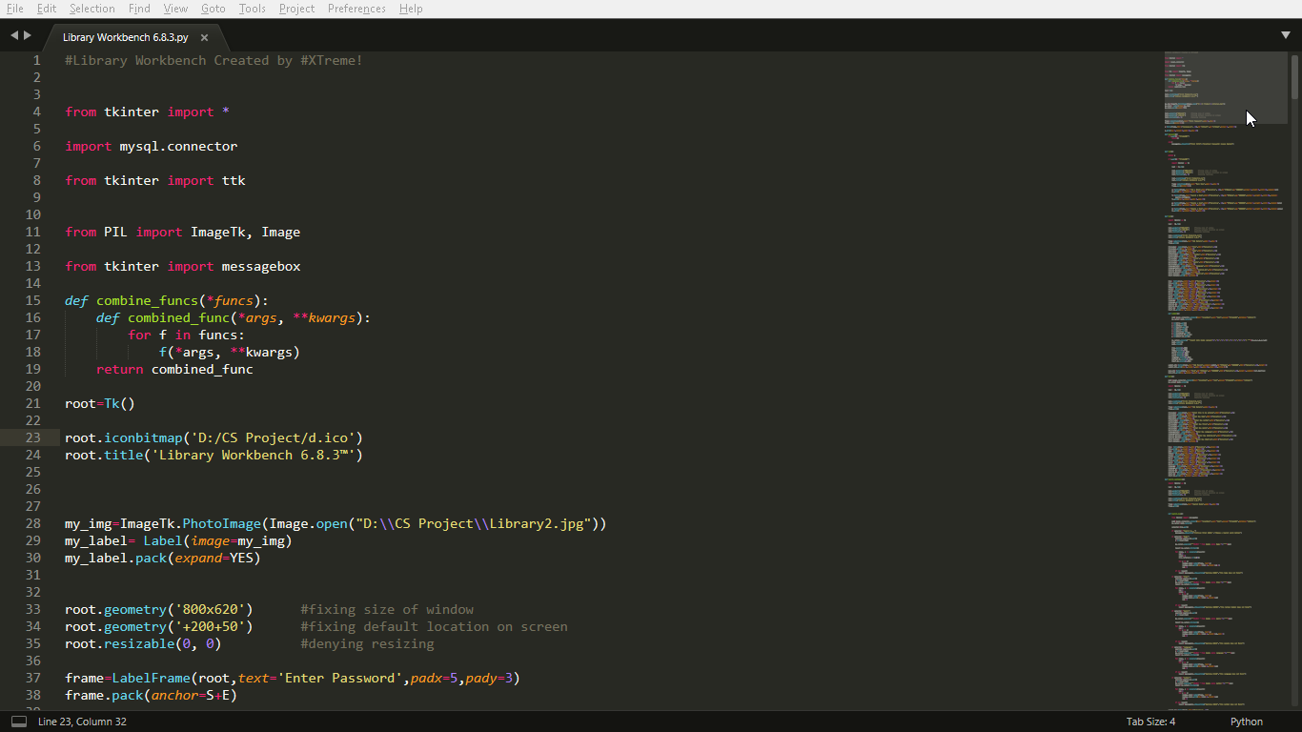

**Figure 1: Source Code of Program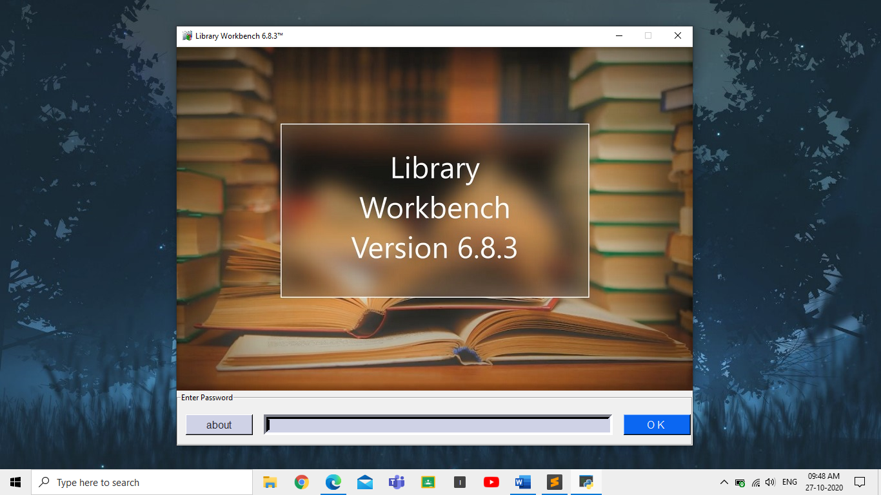 Figure 2: Sign In Page**

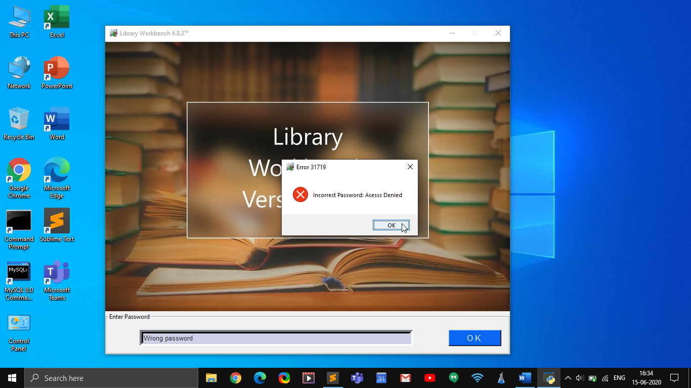

**Figure 3: Denial Of Usage on incorrect password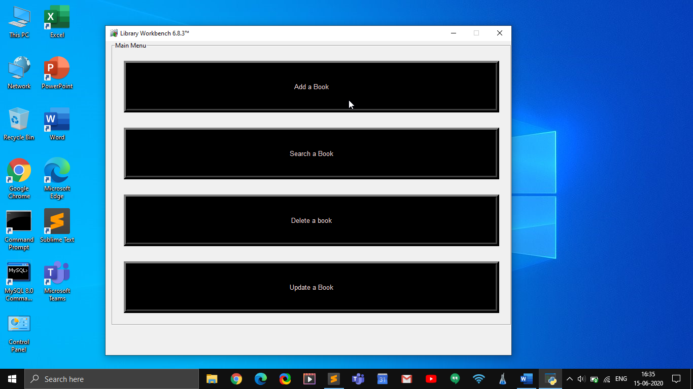 Figure 4: Choosing between various options**

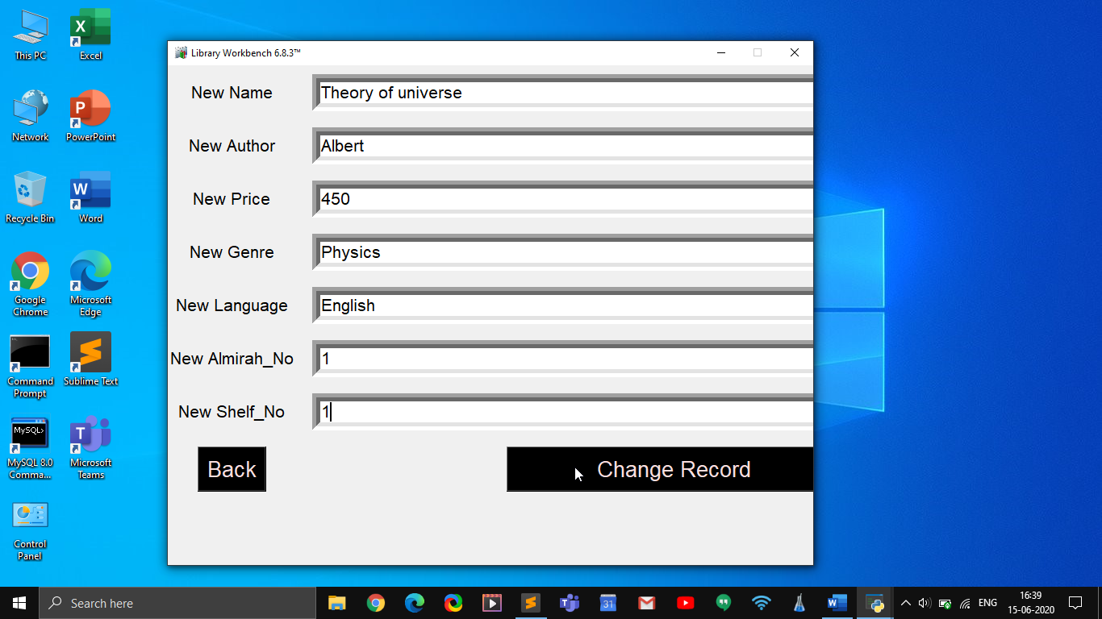

**Figure 5: Adding new Books to Database**

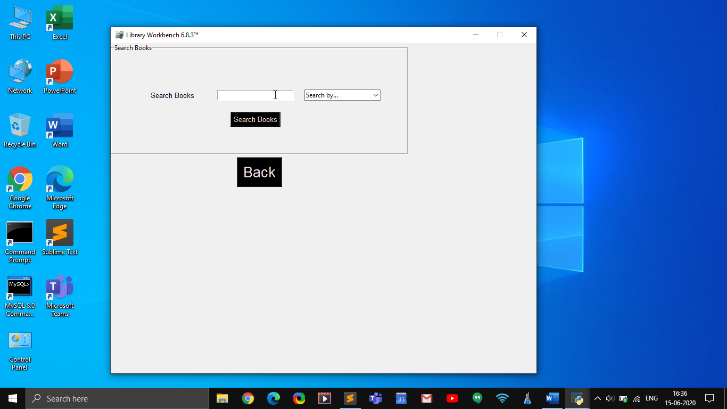

**Figure 6: Search Window**

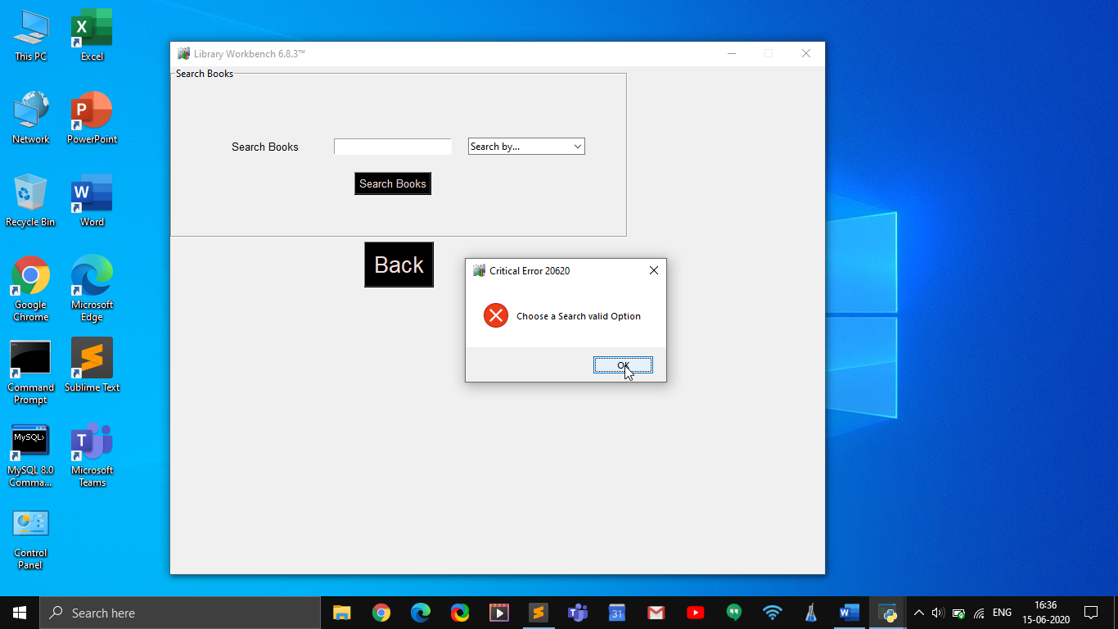

**Figure 7: Error showing to choose a valid option**

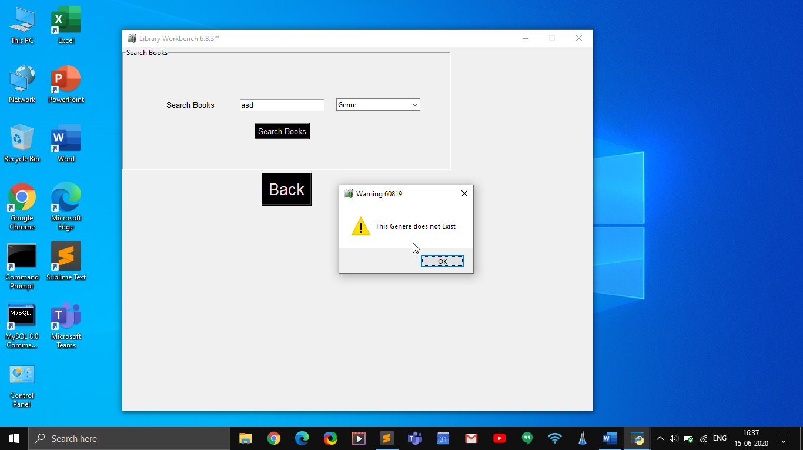

**Figure 8: Warning that no such book exists**

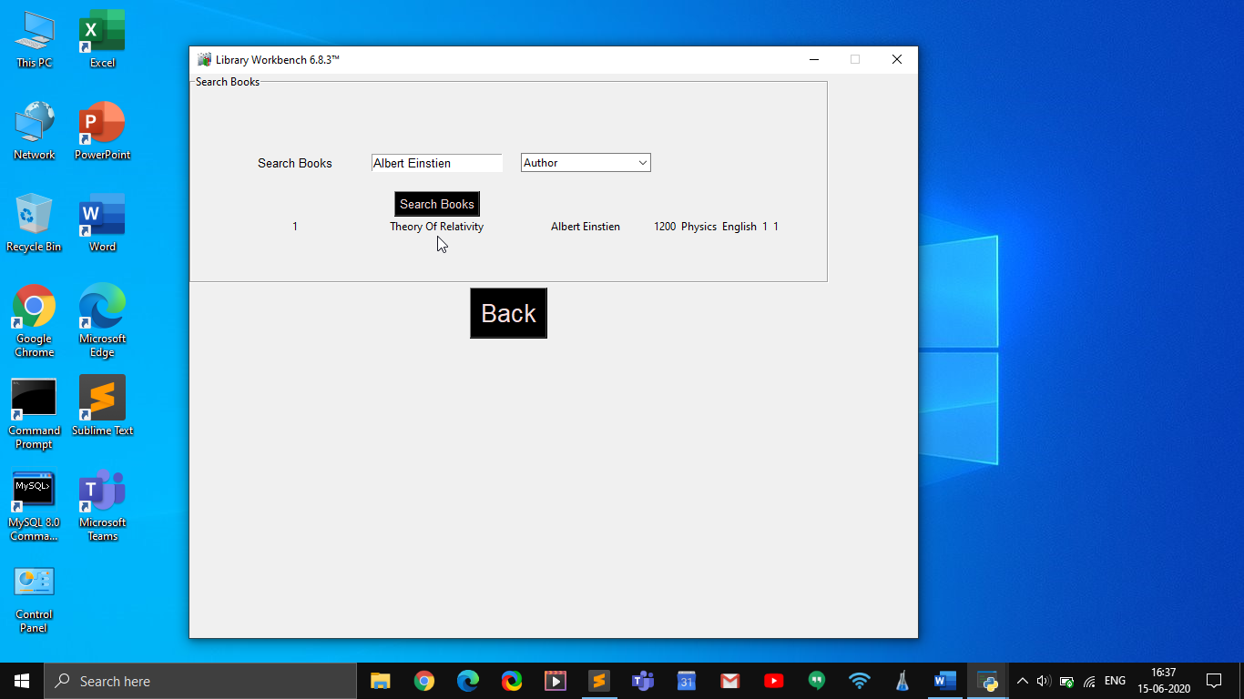

**Figure 9: Search results**

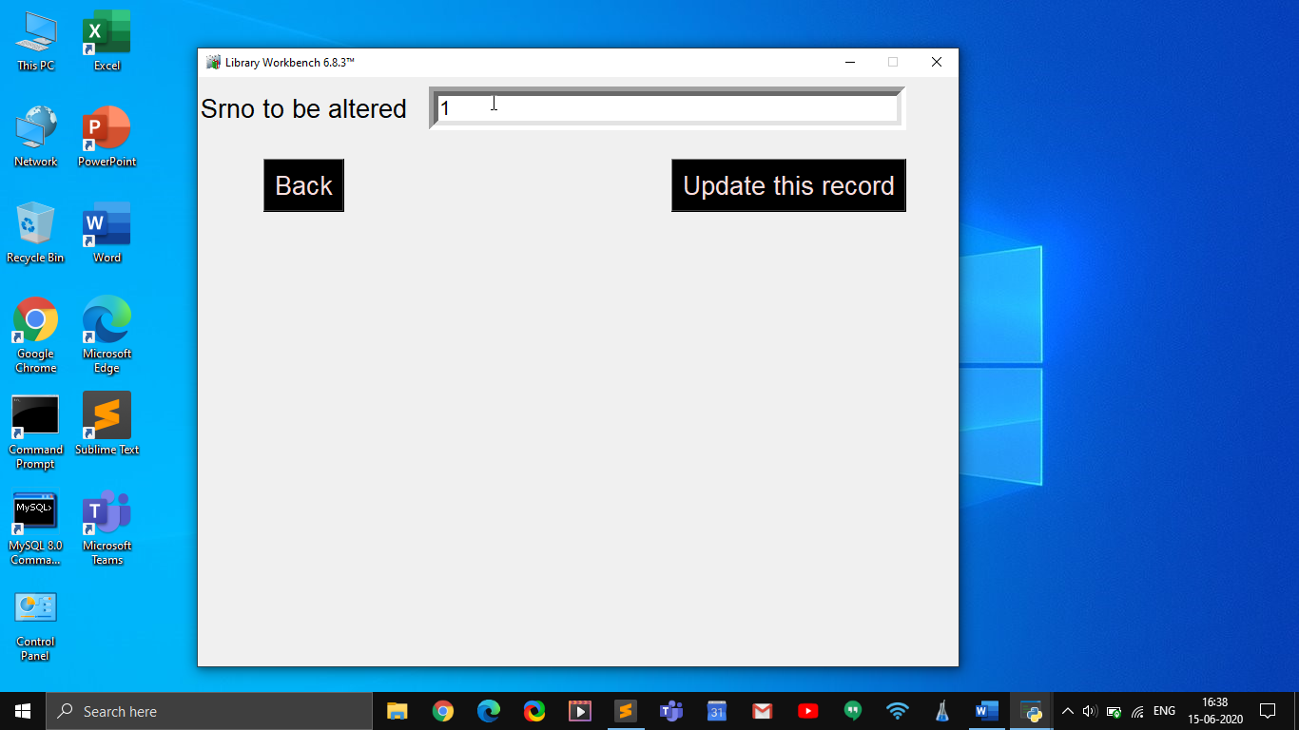

**Figure 10: Update Record Window**

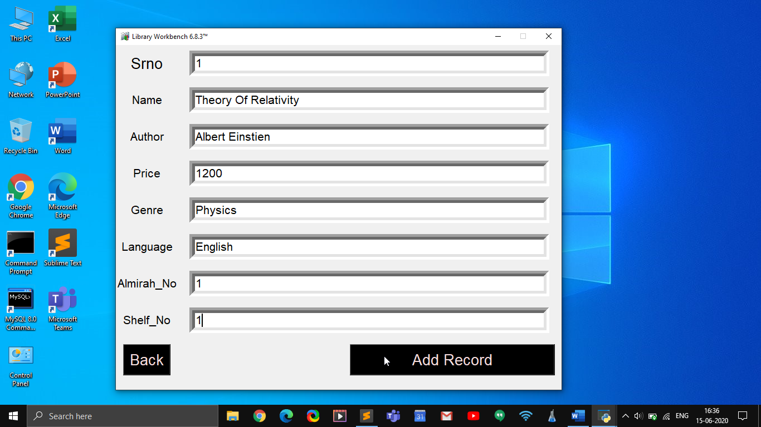

**Figure 11: Updating a Record**

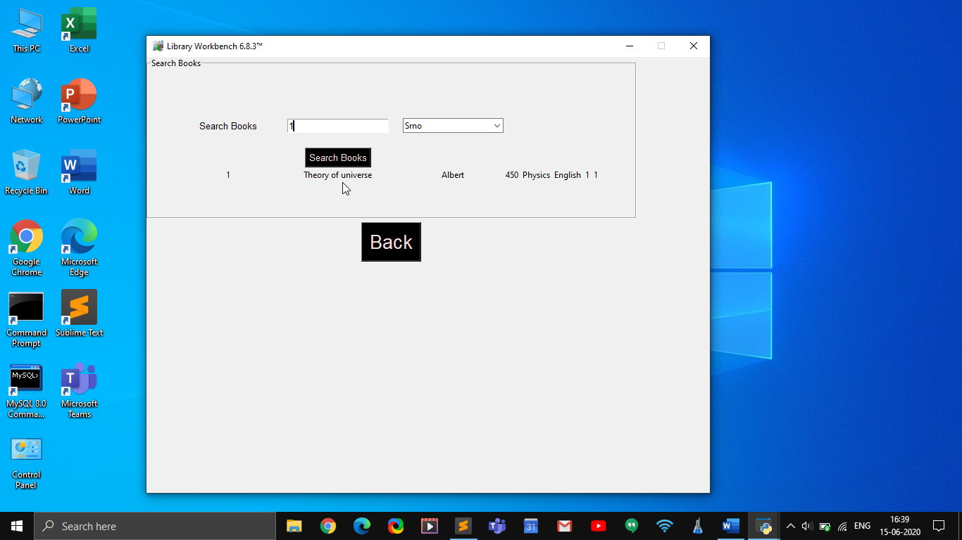

**Figure 12: Searching for updated records**

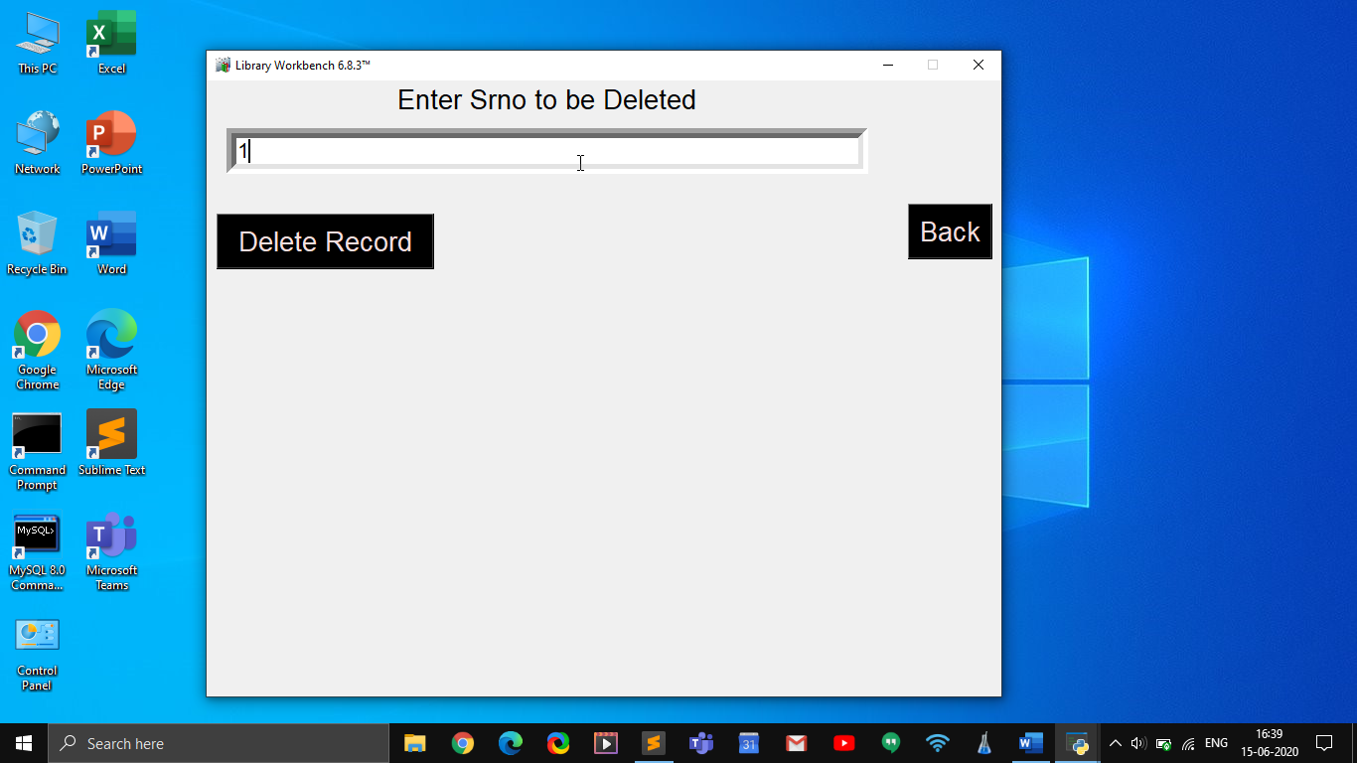

**Figure 13: Deleting a Record**

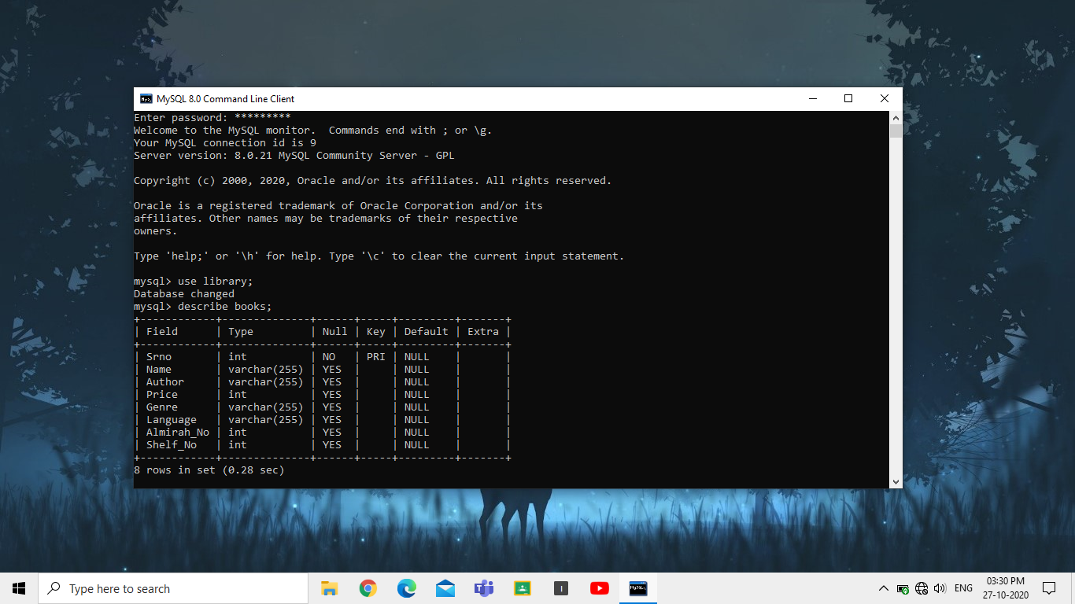

**Figure 14: MySQL Back-End**

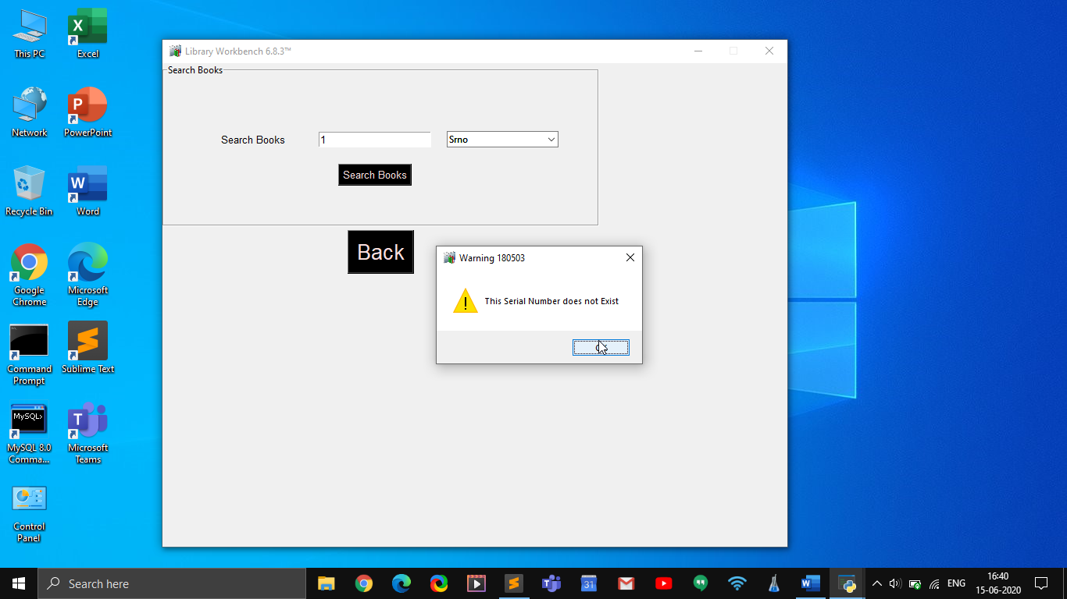

**Figure 15: Warning on search of a deleted record**

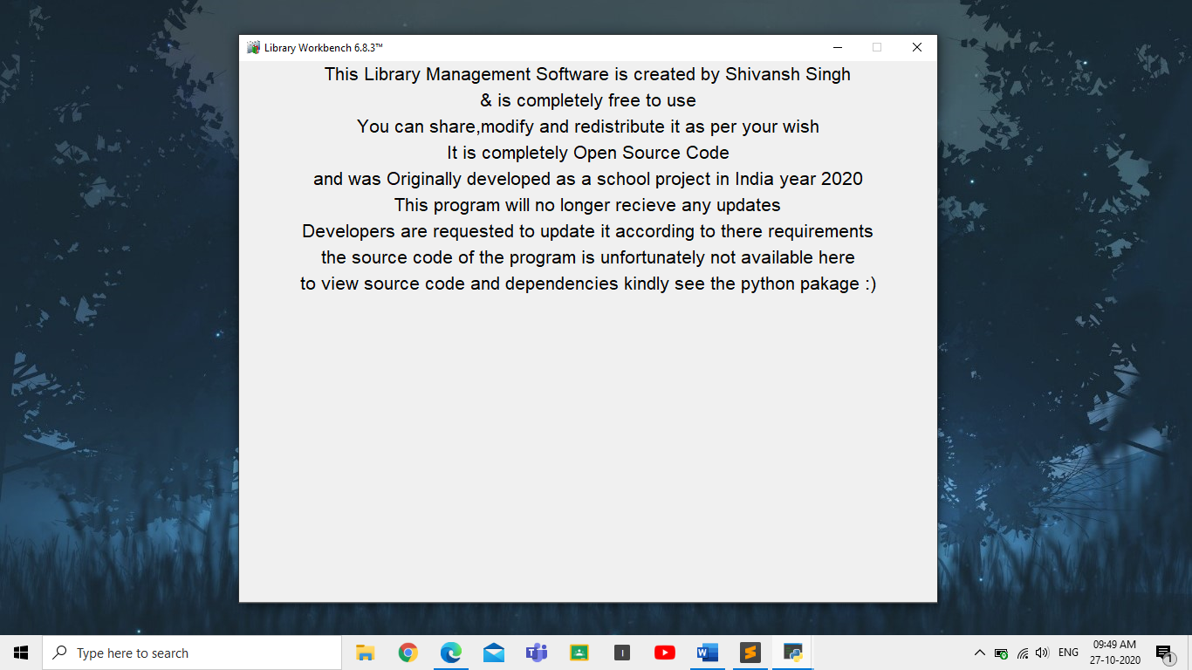

**Figure 16: About Section**

**FUTURE SCOPE**

This project demonstrates basic funcationality of a Library Mangemnet System. More features need to be build into this in order to make it more useful to the end user.

The features that can be added may inlcude rich data features, plus the record of the lending of books to library members.

The software can also be developed to calculate fines and store data of the person to whom book is lend, additionally a functionality to take care of libraries’ financial expenses can be designed.

This can be turned into a web based application for multiple device compatability & portability.

All these value added features will make the product much more useful to the users.

**System Build**

**Operating System : Windows 10 Pro**

**Version : 20H2  
OS Build : 19041.572**

**Processor : Intel® Core™ i3-7020u @2.30GHz**

**RAM : 4.00 GB**

**GPU : Intel® HD Graphics 620**

**Python Version : 3.8.6**

**MySQL Version : 8.0**

**Text Editor Used : Sublime Text 3.2.2 Build 3211**

**Bibliography**

1. **YouTube**
2. **Codemy.com YouTube channel**
3. **Stack overflow**
4. **GitHub**
5. [**www.w3schools.com**](http://www.w3schools.com/)
6. **Edureka live YouTube channel**